CENTRO EDUCACIONAL DE ADULTOS ISABEL LA CATOLICA.
PUENTE ALTO.

ASIGNATURA | INGLÉS | NIVEL | 2° NIVEL
UNIDAD | 1 | APRENDIZAJE ESPERADO | Los alumnos reconocen el uso de tiempo presente perfecto. Tanto en su forma de afirmativo, negativo o pregunta.
OBJETIVO DE LA GUIA. | Aplicar el uso de tiempo presente perfecto. | INDICADORES DE EVALUACION. | El alumno comprenderán a utilizar esta forma verbal y compondrán oraciones utilizando la forma correcta de la gramática.

INSTRUCCIONES PARA EL DESARROLLO DE LA GUIA. | Los alumnos observan el video desde https://www.youtube.com/watch?v=6ATj9Do_RL8  Luego completan los siguientes ejercicios.  Completar el crossword y luego completar las guias como lo solicita.

GUIA Nº 2 | FECHA: 30/03/20 | NOMBRE DE LA GUIA | Use of present perfect.
- Read the clues and complete the crossword. Lee las pistas y compoleta el crucigrama.

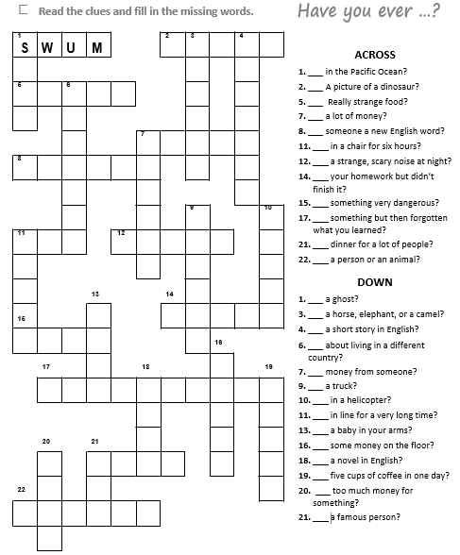

- Re-write the sentences changing to present perfect. Re-escribe las oraciones cambiandolas a presente perfecto.

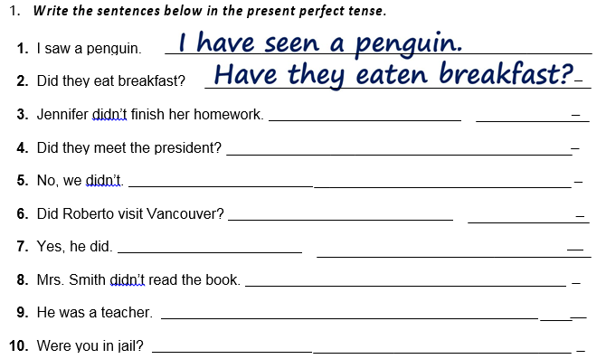

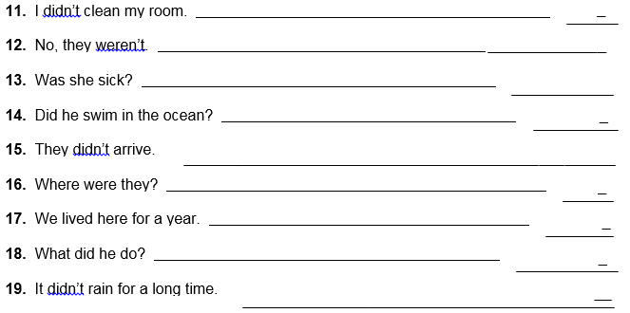

- Circle the correct alternative about present perfect tense tense. (have or has)
21. Andrea and I _____ ______ on the bed. 22.My friend ____ _____ to the moon.

a. have write b. have written a. has go b.has gone
c. hasn’t written d. A and C c. have gone d.has went

23. I ____ _________ to the mountain 24. Cats _______ _______on the roof

a. have drove b. have driven a. has slept b. have slept
c. have not driven d. B and C c. has not slept d. none above

25. _______ you _______ to come? 26. _____ your mom _____ the game?

a. Has planning b. are planing a. has play b. have played
c. Have planned d. Has planned c. have play d. Has played

27. ______ it ________ a lot? 28. ________he________?

a. Have rained b. has rain a. Has read b. has red
c. Has rained d. none above c. Have read d. C and D

