CENTRO EDUCACIONAL DE ADULTOS ISABEL LA CATOLICA.
PUENTE ALTO.

ASIGNATURA | IDIOMA EXTRANJERO INGLÉS | NIVEL | PRIMER NIVEL
UNIDAD | ONE: THE WORLD AROUND ME | APRENDIZAJE ESPERADO | Identificar y localizar la información principal y algunos detalles de la información secundaria de textos escritos.  Responder apropiadamente, en castellano si fuera necesario, a las tareas que el texto demanda para demostrar comprensión de la información.
OBJETIVO DE LA GUIA. | Los alumnos leen y comprenden textos escritos descriptivos, auténticos y adaptados de aproximadamente 30 palabras significativas del presente simple del To Be. Responden por escrito en inglés o español con oraciones simples y cortas. | INDICADORES DE EVALUACION. | DISTINGUE LOS DIFERENTES TIPOS DE ORACIONES EN UN TIEMPO VERBAL EN LA PRODUCCIÓN DE TEXTOS ESCRITOS.  IDENTIFICA LAS IDEAS BÁSICAS DE LOS TEXTOS RESPONDIENDO A LAS PREGUNTAS YA SEA EN INGLÉS O ESPAÑOL.

INSTRUCCIONES PARA EL DESARROLLO DE LA GUIA. | Lea atentamente cada instrucción de cada ítem y complete ayudándose del diccionario www.wordreference.com  Además, vea atentamente los dos videos sugeridos, ya que facilitarán sus asignaciones.  No utilice traductor, ya que éste lo hará cometer más errores que el diccionario.

GUIA Nº 1 | FECHA: 18-03-2020 | NOMBRE DE LA GUIA | NEWS

CONTENIDO:

PRESENT SIMPLE OF TO BE VERB:

TO BE TRADUCCIÓN (SER O ESTAR)

I AM… YO SOY O YO ESTOY…

YOU ARE… TÚ ERES O TÚ ESTÁS…USTED ES O USTED ESTÁ

HE IS… ÉL ES O ÉL ESTÁ…

SHE IS… ELLA ES O ELLA ESTÁ…

IT IS… ES O ESTÁ…

WE ARE… NOSOTROS O NOSOTRAS SOMOS O ESTAMOS…

YOU ARE… USTEDES SON O ESTÁN…

THEY ARE… ELLOS O ELLAS SON O ESTÁN…

PARA MAYOR INFORMACIÓN Y EXPLICACIÓN VISITA LAS PÁGINAS:

https://www.youtube.com/watch?v=9p-_NhWuuZQ PARTE 1 FORMA AFIRMATIVA Y NEGATIVA .

https://www.youtube.com/watch?v=nxInU3NnkKU PARTE 2 FORMA DE PREGUNTA.

I.- Read the following text about COVID-19 virus.

I.- Lea el siguiente texto sobre el virus del COVID-19.

A.- Are antibiotics effective in preventing and treating the new coronavirus?
No, antibiotics do not work against viruses, only bacteria.
The new coronavirus (2019-nCoV) is a virus and, therefore, antibiotics should not be used as a means of prevention or treatment.
However, if you are hospitalized for the 2019-nCoV, you may receive antibiotics because bacterial co-infection is possible.

B.- Cold weather and snow CANNOT kill the new coronavirus.
There is no reason to believe that cold weather can kill the new coronavirus or other diseases. The normal human body temperature remains around 36.5°C to 37°C, regardless of the external temperature or weather. The most effective way to protect yourself against the new coronavirus is by frequently cleaning your hands with alcohol-based hand rub or washing them with soap and water.

C.- Are hand dryers effective in killing the new coronavirus?
No. Hand dryers are not effective in killing the 2019-nCoV. To protect yourself against the new coronavirus, you should frequently clean your hands with an alcohol-based hand rub or wash them with soap and water. Once your hands are cleaned, you should dry them thoroughly by using paper towels or a warm air dryer.

ANSWER THE QUESTIONS IN SHORT FORM IN SPANISH OR ENGLISH.
CONTESTA LAS PREGUNTAS EN FORMA CORTA EN ESPAÑOL O INGLÉS.

1C.- Are hand dryers effective killing 2019-nCoV?

2C.- Are you washing your hands frequently?

A.

D.- Does the new coronavirus affect older people, or are younger people also susceptible?
People of all ages can be infected by the new coronavirus (2019-nCoV). Older people, and people with pre-existing medical conditions (such as asthma, diabetes, heart disease) appear to be more vulnerable to becoming severely ill with the virus.
WHO (World Health Organization) advises people of all ages to take steps to protect themselves from the virus, for example by following good hand hygiene and good respiratory hygiene.

ANSWER THE QUESTIONS IN SHORT FORM IN SPANISH OR ENGLISH.
CONTESTA LAS PREGUNTAS EN FORMA CORTA EN ESPAÑOL O INGLÉS.

1D.- Are younger people affecting by the 2019-nCoV?

A.-

2D.- Am I taking the steps to protect my family and I by the virus?

A.-

II.- Translate into Spanish the text A and B.
II.- Traduzca al español el texto A y el B
A.-

B.-

III.- Make statements in English in affirmative, negative and question form with words: virus, bacteria, hospitalized, cleaned. Use TO BE verb.
III.- Haz oraciones afirmativas, negativas y en forma de pregunta con las palabras: virus, bacteria, hospitalizado(a), limpio(a). Usa el verbo To Be.
HAZ LAS ORACIONES EN INGLÉS.
VE LOS VIDEOS PARA MAYOR COMPRENSIÓN YA QUE TE FACILITARÁ HACER LAS ORACIONES.

Example: It is a very dangerous bacteria. (affirmative)
It is not a very dangerous bacteria. (negative)
Is it a very dangerous bacteria? (question form)

AFFIRMATIVE FORM

1.-

2.-

3.-
NEGATIVE FORM
1.-
2.-
3.-
QUESTION FORM
1.-
2.-
3.-

IV.- Complete the following statements with TO BE verb in present simple tense. AM-IS-ARE
IV.- Completa las siguientes oraciones con el verbo to be en presente simple.
VE LOS VIDEOS PARA UNA MAYOR COMPRENSIÓN YA QUE TE FACILITARÁ COMPLETAR LAS ORACIONES.

Example: Maria ____is ____ in the house.
(affirmative)

1.- Andrea ________ sick but she _________in the hospital, she ________in her house. She
(affirmative) (negative) (affirmative)

has only cough.
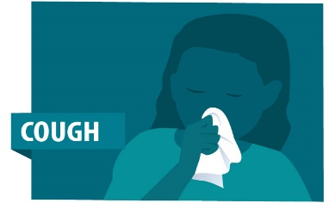

2.- My husband _________ in the hospital, because he has shortness of breath, but I _______
(affirmative) (affirmative)

calm because he _________ in an excellent hospital.
(affirmative)
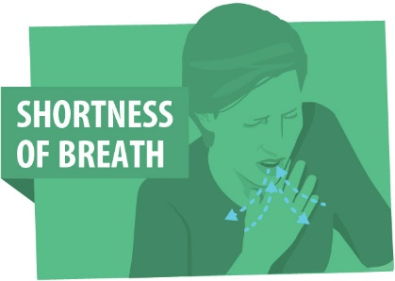

3.- John and Clark have fever, they ________ in their house with their family. They__________
(affirmative) (affirmative)

happy, because they__________ seriously ill, they just have flu.
(negative)
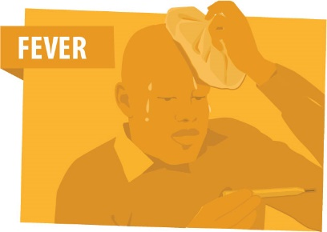
If you have fever over 38°, shortness of breath and cough go to the hospital, you need medical care.
Take care of you!
Your teacher.

