**Tarea día martes 17 de marzo**

* Transforma a manuscrita las vocales.( a- e- i – o- u)

|  |  |  |  |
| --- | --- | --- | --- |
| A | A | A | A |
|  |  |  |  |
|  |  |  |  |
|  |  |  |  |



|  |  |  |  |
| --- | --- | --- | --- |
| E | E | E | E |
|  |  |  |  |
|  |  |  |  |
|  |  |  |  |



|  |  |  |  |
| --- | --- | --- | --- |
| I | I | I | I |
|  |  |  |  |
|  |  |  |  |
|  |  |  |  |



|  |  |  |  |
| --- | --- | --- | --- |
| o | o | o | o |
|  |  |  |  |
|  |  |  |  |
|  |  |  |  |



|  |  |  |  |
| --- | --- | --- | --- |
| u | u | u | u |
|  |  |  |  |
|  |  |  |  |
|  |  |  |  |



**Tarea día miércoles 18 de marzo**

* Practica esta hermosa tarea de grafomotricidad, puedes hacerlo utilizando

colores y siguiendo las líneas segmentadas.

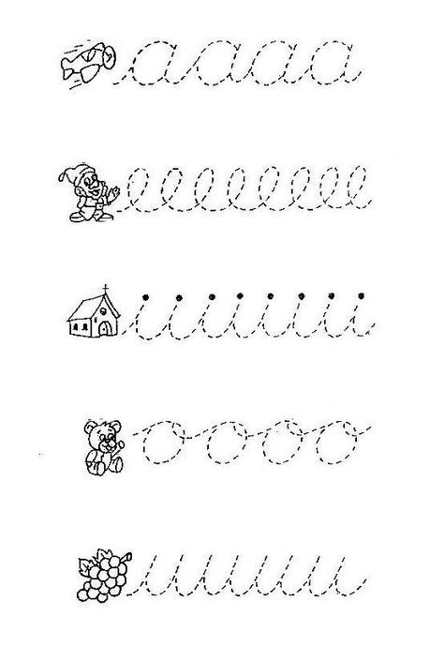



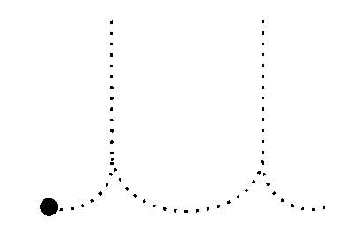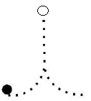

**Tarea día jueves 19 de marzo**

* Practiquemos la grafía de los números del 1 al 10

|  |  |  |  |  |  |  |  |  |  |
| --- | --- | --- | --- | --- | --- | --- | --- | --- | --- |
| 1 | 2 | 3 | 4 | 5 | 6 | 7 | 8 | 9 | 10 |
|  |  |  |  |  |  |  |  |  |  |
|  |  |  |  |  |  |  |  |  |  |

* Observa el número y pega bolitas de plastilina según la cantidad que te indique.

6

10

5

2

9

**Tarea día viernes 20 de marzo**

Cuenta las cantidades y grafica el número que corresponde.

